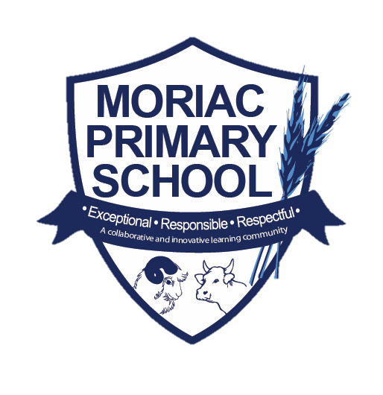
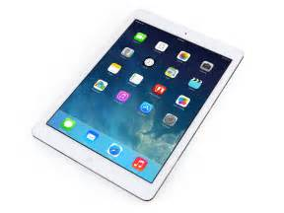

.
iLearn Program 2021

Introduction

Moriac Primary School operates a 1:1 Device Program for students in years 3-6.

The iLearn program provides an opportunity for our students to enter a new world of curriculum possibilities, allowing greater engagement and involvement in their learning. Learning experiences across the school are purposefully designed to develop the attributes of a life-long learner. In this way, each student learns to develop and demonstrate the knowledge, skills, practices and attitudes necessary to be an engaged, robust, 21st century citizen capable of shaping our future.

Please be advised that year 3 - 6 teachers plan with the specific intent that that every child has an iPad in hand. This does not mean though every moment involves using technology. It is on a needs basis.

Specific Details about the iLearn Program

The program will be a Bring Your Own Device (BYOD) Program.
One-to-one learning allows every student access to their own device in a wireless environment, allowing them to learn at their own pace and ability levels . One-to-one initiatives have gained momentum worldwide, and are increasingly seen as a key to transforming education and better preparing students to succeed in the new world.

In the iLearn Program, students' access to an iPad and the internet enables them to be self-directed and receive highly personalised instruction. Students use their personal devices to do research, homework, problem-solve, team projects, email and academic coursework.

Families can purchase iPads from any store they wish as long as the iPad meets the mandatory requirements below.

MININUM iPAD REQUIREMENTS:

- An iPad must be at least any version of iPad with a lightning charger
- We highly recommend 8th Gen devices
- Device must be running the latest iOS.
- ALL devices must be WiFi ONLY. Strictly no 3G capable device will be permitted at school.
- All iPads must have a protective case.

The School has a partnership with JB HiFi which offers very competitive educational prices. As part of this portal you also have access to insurance and AppleCare. To access the JB HiFi educational portal please use the following link:

https://www.jbeducation.com.au/byod/

school code is: Moriac2021

*This site has lots of accessories that you can purchase for the iPad, the minimum requirements are the iPad and a protective case, you do not need the other accessories to participate in the program.

How long will the iPad last

Apple products are generally more solid and reliable than other products. The lifespan of an iPad is approximately 3 years. With care, the life of the iPad can be prolonged beyond this.

Apps and Management

Our teachers have put together a list of required Apps that have been recognised as purposeful in enabling students to be productive in their learning and would be valuable to use at home. They are well researched Apps that can be used throughout primary school as a tool to support and reinforce the general learning process. The required Apps can be found and the end if this document.

Internet Usage

The internet service within the school network is closely monitored by a filtering system which allows for inappropriate content blocking by a regularly updated list of categories and sites. This does not apply to use of devices outside of the school network. Education and support are important for maintaining acceptable use of devices, particularly in relation to internet access.

Parents and students should also familiarise themselves with the Acceptable Use Policy to further support their adherence outside of the school environment. Any inappropriate use of the internet is unacceptable and is subject to disciplinary action and exclusion from the school networks and resources.

Non - School Applications and Files

Software, including music, movies and games will be allowed for academic and recreational reasons, provided copyright obligations are met and the highest ratings are PG. No games, music or movies that contain obscene language or offensive content are permitted. Downloading music, games and videos from the internet during school hours is prohibited except when directed by a staff member.

Power Supply Management

IPads must be fully charged at the commencement of every day. Chargers are not to be brought to school due to OH&S regulations as they could be a trip hazard and haven’t been tagged and tested which is a Department of Education requirement.

Backup and Recovery

Students will be responsible for their own backup of critical data at all times. Logging into iCloud is the best way to back up any important files on the iPad.

Advice for Parents

The School believes the teaching of cyber safety and ethical online behaviour is essential in the lives of students and is best taught in partnership between home and school. 21st Century students spend increasing amounts of time online learning and socialising. These online communities need cybercitizens who do the right thing by themselves and others online, particularly when no one is watching. Safe and ethical behaviour online is explicitly taught at our school and support at home is requested. It is important to note that some online activities are illegal and as such will be reported to police. This includes harassment of others and publishing of inappropriate images.

Some suggested guidelines for using iPads at home:

- do not let students keep their iPad in their room overnight, it is too tempting.
- set boundaries for how much students use their iPad at home, an hour a night is more than enough screen time.
- always know your child’s passcode, this helps if they forget it and also allows you to monitor the content of their iPad.
- limit how many games are on the iPad, we suggest only three games on the device at any one time. Using all the storage on the iPad reduces the device’s performance.
- students are taught cyber safety at Moriac PS, but the best solution is calm and open communication with your child about how to communicate online.

Three things parents can do today:

KEEP CURRENT with the technology and web services your child uses, ‘Friend’ them on Facebook and follow them on any social media they use. Pay attention to who their friends are. Know how to use the reporting and privacy functions and set an example of flagging inappropriate content or behaviour when you see it.

KEEP COMMUNICATING find out what your child is using the internet for and whom they are communicating online with. Have the computer in a shared place in the house (not the child’s bedroom). Constantly ask questions, ensuring open line of communication

KEEP CHECKING your child’s internet use, iPad and phone activity. Inappropriate material is often hidden with different file names and stored within a folder.

What is the School’s Acceptable Use Policy?

To participate in this program, students must demonstrate commitment to being a responsible learner. This means meeting attendance and punctuality standards and using their device in strict accordance with the School’s Acceptable Use Policy.

Moriac PS use the internet and digital technologies as teaching and learning tools within student learning. We see the internet and digital technologies as valuable resources, but acknowledge they must be used responsibly.

At Moriac PS we:
- have policies in place that outline the values of the school and expected behaviours when students use digital technology and the internet.
- provide a filtered internet service.
- provide supervision and direction in online activities and when using digital technologies for learning.
- support students in developing digital literacy skills.
- have a Learning to Learn program that focuses on cyber safety.
- use mobile technologies for educational purposes (e.g. sharing educational videos)
- provide support to parents/carers to understand our policies (e.g. language support).
- provide support to parents/carers through information evenings.
- work with students to outline and reinforce the expected behaviours.

Our Acceptable Use Policy is attached on the next page. If you have any further queries or concerns in regards to this document or the use of internet and digital technologies at Moriac PS please do not hesitate to contact the school.

The Acceptable Use Policy is outlined in the following pages: Students will need to sign the Student User Agreement to use their device. This will be sent out at the start of 2021.
At the start of the year, once the user agreement is signed, students will receive their unique school-user credentials: username and network password. These passwords will be their own, however teachers will keep track of these passwords. The unique school-user credentials allow us to safely monitor ICT usage and browsing history. Furthermore, we must note, that various social media platforms and apps (including Facebook, Instagram, Snapchat, YouTube, etc) are blocked for student access.

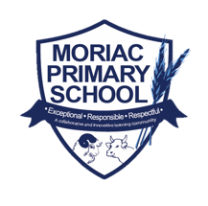
Classroom ICT & Internet Acceptable Use Policy

Vision

To create citizens that are digitally literate for the 21st century by purposefully designing curriculum that transforms the way students learn, allowing greater engagement and involvement in their learning.

Physical Safety

Students are expected to:
- Never leave technology on the floor or take technology outside of the classroom without the teacher’s permission.
- Never lend technology to peers, even with permission.
- Never take photos of fellow students, unless a student gives written permission and the photo is relevant to the learning task.
- Take responsibility for their own technology, storing their technology safely in their bags before school and within the classroom during recess and lunchtimes.
- Report any damage or misuse immediately.
- Keep all food and drink away from devices.

Communication and the Internet

Students are expected to:
- Only access appropriate websites that have a positive impact on their learning.
- Communicate responsibly and respectfully in an online environment.
- Never access or use instant messaging apps or social media websites at school.
- Respect the privacy of others in an online environment. It is not acceptable to publish images or videos of other students.
- Only login to their own accounts and never share passwords with others.

Content on Personal Learning Devices

Students are expected to:
- Respect other students’ property and use equipment appropriately.
- Never share inappropriate files via the school network or USB storage devices.
- Ensure their device is charged and ready for a full day’s work.
- Follow teachers’ instructions regarding use of their device.

Consequences

If students do not adhere to this acceptable use policy, classroom teachers will use the following steps as consequences.

1st breach of policy | Access to technology is removed for the learning session
2nd breach of policy | Access to technology is removed for the day. Parent is contacted.
Severe breach of policy | Access to technology is removed for a week. Parent is contacted.  Meeting arranged with the relevant Assistant Principal.

App | Icon | Possible App Uses / Description
Google Drive | 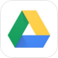 | Online file storage. Save work files in Drive, access from any device and share them instantly.
Google Classroom |  | Helps teachers create and organize assignments quickly, provide feedback efficiently, and easily communicate with their classes. Classroom helps students organize their work in Google Drive, complete and turn it in, and communicate directly with their teachers
Google Docs | 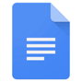 | Co-edit documents, spreadsheets, and presentations in real time. Just like Microsoft Word, Excel and PowerPoint.
Google Sheets | 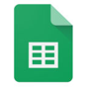
Google Slides
Google Keep |  | Build to-do lists, create task reminders.
Seesaw: Class | 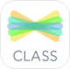 | Seesaw is a student-driven digital portfolio. Seesaw empowers students of any age to create, reflect, collaborate and share. Invite families to Seesaw to keep them in the loop about their child’s learning, and easily communicate between school and home.
Pic Collage |  | Edit photos, make free cards, and create photo collages. Choose from hundreds of photo grid layouts and sizes, exclusive stickers, background patterns and textures, and draw on your collages.
Adobe Spark Page | 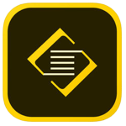 | Spark Page makes it easy for anyone to turn words and images into a beautiful gliding webpage story. You can transform a newsletter, report, invitation or travel adventure into a visual story that delights readers on any device.
Canva | 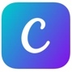 | Create beautiful designs and professional graphics with Canva. Whether it’s a photo editor, pic collage, logo, invitation or poster maker you’re looking for — Canva makes graphic design easy.
iMovie |  | Create movies quickly and effortlessly.
QR Reader for iPad | 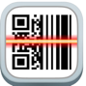 | Opens web pages quickly and efficiently using QR codes.
Kahoot |  | Play fun learning games and cool quizzes to help teach content to the students.
Epic! Books |  | Digital library for kids, where kids can explore their interests and learn with instant, unlimited access to 25,000 high-quality ebooks, audiobooks, learning videos, and quizzes for kids 12 and under.
Garageband |  | GarageBand turns your iPad, and iPhone into a collection of Touch Instruments and a full-featured recording studio — so you can make music anywhere you go.

