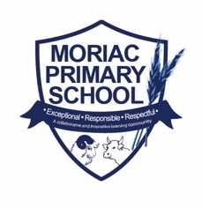
Form 2: Notice of Election and Call for Nominations
An election is to be conducted for members of the school council of Moriac PS.

Nomination forms may be obtained from the school and must be lodged by 4.00pm on Friday 25/2/2022.
Nomination forms should be returned to the Office or
emailed directly to Mark Zahra, Principal at mark.zahra@education.vic.gov.au
The ballot will close at 4.00pm on Friday 11/3/2022 if we need the amount of nominations is greater than the number of positions.

Following the closing of nominations a list of the nominations received will be posted at the school.

The terms of office, membership categories and number of positions in each membership category open for election are as follows:

MEMBERSHIP CATEGORY | TERM OF OFFICE | NUMBER OF POSITIONS
Parent Member (2 Year Term) | From the day after the date of the declaration of the poll in 2022 to and inclusive of the date  of the declaration of the poll in  2024 | 4
School Employee Member (2 Year Term) | From the day after the date of the declaration of the poll in 2022 to and inclusive of the date  of the declaration of the poll in  2024 | 2

